Architecture Solution Design

IAM Pull Request Automation

[RITM1149048 | ACBSD-4272]

Version Control
Version Control |  |  |  |  | Approvals
Version | Date | Author/  Updated By: | Status | Comment | Pre-ARB | GTS ARB | Global ARB | GITB
01.00.00 | 2026-03-05 | Mohamed Kerbachi | Initial Document |  | ☐ | ☐ | ☐ | ☐
 |  |  | Choose an item. |  | ☐ | ☐ | ☐ | ☐
 |  |  | Choose an item. |  | ☐ | ☐ | ☐ | ☐
 |  |  | Choose an item. |  | ☐ | ☐ | ☐ | ☐
 |  |  | Choose an item. |  | ☐ | ☐ | ☐ | ☐
 |  |  | Choose an item. |  | ☐ | ☐ | ☐ | ☐
 |  |  | Choose an item. |  | ☐ | ☐ | ☐ | ☐

Table of Contents
Version Control 2
Table of Contents 3
1. Distribution and Contacts 6
2. Artifacts 7
3. Summary 8
3.1 Background 8
3.2 Solution Description 8
3.3 Business Unit(s) Impacted 8
4. Requirements 9
4.1 Use Cases 9
4.1.1 Use Case Requirements 9
4.1.2 Business Requirements 9
4.2 Functional Requirements 9
4.3 Non-Functional Requirements 10
Observability, Logging and Monitoring Requirements 10
Fault Tolerance & Resiliency Requirements 10
Availability Objectives 10
Performance Requirements 10
Capacity Requirements 10
4.4 Security Requirements 11
Security Requirement 11
4.5 Data Requirements 11
Data Requirement 11
4.6 Capability Map 11
5. Architecture 12
5.1 Alignment to Principles 12
5.2 Baseline Architecture 13
5.3 Target Architecture 14
5.3.1 Overview 14
5.3.2 Technology Components & Architecture Impacts 14
5.3.3 Gap Analysis 15
6. Components 16
6.1 Components or Patterns Used 16
6.1.1 Component Architecture Diagram 17
6.1.2 Components or Pattern Table 17
6.2 Integration Architecture 18
6.2.1 Integration Architecture Diagram 18
6.2.2 Integration Architecture Table 18
6.3 Data Flow 18
6.3.1 Data Flow Diagram 19
6.3.2 Data Flow Table 19
6.4 Data Protection 20
6.4.1 Backup and Recovery 20
6.4.2 High Availability 20
6.4.3 Disaster Recovery 20
6.5 Observability 20
6.6 Authentication and Authorization 20
6.7 Security Boundaries 20
6.7.1 Security Boundaries Diagram 20
6.7.2 Security Boundaries Table 21
6.7.3 Security Review Outcomes 21
6.7.4 Threat Model Assessment 21
7. Data Solution 22
7.1 Data Classification 22
7.2 Privacy Impact Assessment (PIA) 22
7.3 Data Encryption 22
7.4 Data Retention 22
7.5 Data Residency 22
7.6 GenAI 22
8. Service Model 24
8.1 Shared Responsibilities 24
8.2 RACI Chart 24
9. Implementation Approach 26
9.1 Proposed level of coordination 26
9.2 Dependencies 26
10. Waivers and/or Exceptions 28
10.1 Risk Acceptances 28
10.2 Risk Remediations 28
10.3 Security Exceptions 28
11. Estimated Costs 30
11.1 Financial Considerations 30
11.2 Non-Financial Considerations 30
11.3 Cost Benefit Analysis 30
11.4 Licensing 31
11.5 Financial Assumptions 31
11.6 Resourcing Considerations 31
12. Exit Strategy 32

Distribution and Contacts
Use confluence link to find contacts for the below section. Delete red text when done.
Link: ISO, DPO and Architects - GTS Architecture Solution Design - Global IT Confluence Production (aegon.com)
This document and future updates to be shared with the business representatives shown below.
Business Contacts and Information
Requester
Business DPO
Business ISO
Business Architect
BCP Manager
Business Unit
Cost Center
Cost Center Owner
Product / Service Owner
GTS Contacts and Information
GTS DPO | Adam Kaminski & Emma Warner
GTS ISO | David Innes, Nick Russell & Daniel Lartey
GTS Architecture | Mohamed Kerbachi
GTS Technology Risk Assessment | Matyas Vajda, Rachel Singewald
GTS/Corp Centre GenAI Working Group | Guy Dye

Artifacts
Review Process and Acknowledgements
In Scope | Owner | Non-Architecture Review / Assessment Process | Point of Contact | Link to Acknowledgement or Evidence
☐ | First Line Risk & Controls | Technology Risk Assessment (only for Core and Common designs) | Rachel Singewald, Matyas Vajda | Link
☐ | GTS – Information Security | Information Security Review (process in development and will replace security review section) | David Innes, Nick Russel, Daniel Lartey | Link
☐ | GTS – Information Security | Threat Model | Paul Nickelson, Jeff Bain | Link
☐ | Data Privacy | Data Privacy Impact Assessment (OneTrust) | Adam Kaminski | DPIA Number
☐ | GTS - Architecture | Approved Architectural Artifacts Added to Architecture Repository | Assigned Architect | Link to Repo
☐ | GTS/Corp Centre GenAI | GenAI Inventory & Working Group Communication | Guy Dye | GenAI Inventory ID

Architecture review checklist
Role | Name | Status
Infrastructure Architect |  | Not read
Enterprise Architect |  | Not read
Solution Architect |  | Not read
Security Architect |  | Not read
Enterprise Technology AI Architecture | Preethi Siddula | Not read

Stakeholders review checklist
Role | Name | Status
Enterprise Technology DPO | Adam Kaminski or Emma Warner | Not read
Enterprise Technology ISO | Nick Russell or Daniel Lartey | Not read
Enterprise Technology Risk Assessment | Rachel Singewald or Juan Irizarry | Not read
Cloud Infrastructure | Tiffany Boisen or John Hegyi | Not read

Summary

Background
Describe the business need, objective, and value for the solution. Describe the relevant drivers and constraints for the solution.
Text
The IAM policies management is defined by a manual security review process for pull requests that occur within the Cloud Fusion and Cloud Foundation pipelines, specifically for federated IAM roles and permission changes. Currently, the Cloud Security Engineering Team must manually initiate and resolve Jira tickets for every required approval, a dependency that acts as a primary bottleneck for deployment speed. This existing reliance on human intervention for the security review portion of the IAM pipeline occurs even though other segments of the pipeline have already established automated processes. As a result, engineers are forced to prioritize repetitive manual reviews over higher-value work, and business units face extended timelines for critical role deployments.

Solution Description
Describe the desired outcome.
Text
The desired outcome is an automation system that reduces manual review effort by 70% and provides validation feedback within 10–15 seconds. This solution replaces human bottlenecks with parallel security and compliance checks and an advisory LLM, while a dedicated regression workflow ensures accuracy against historical human decisions. The usage of LaunchPad Gateway is mandatory to access any LLM models.

Business Unit(s) Impacted
The following Country/Business Unit(s) will be impacted by this Solution Design:
☐ | TA | ☐ | GTS | ☐ | Spain
☐ | UK | ☐ | HR Global | ☐ | TLB
☐ | NL | ☐ | ASIA/TLB | ☐ | Global
☐ | Corporate Centre | ☐ | AAM | ☐

Requirements

Use Cases
If applicable
Key Objectives
Scope

Use Case Requirements
If applicable, delete if not required. May be covered in 3.1 Use Cases
Goal | Actor(s) | Pre-conditions | Description of how actor achieves goal | Scenario type

Business Requirements
Document business requirements or additional technical requirements that must be accounted for within the solution design. If there are no additional requirements, then state N/A.
MoSCoW based priority.
Must-haves: critical requirements that are essential for the project’s success. These requirements are mandatory and must be included in the project scope.
Should-haves: high-priority features that are not critical to launch.
Could-haves: requirements that are desirable but not necessary.
Won’t-haves: requirements that are not included in the project scope.
Business Requirements
Req. # | Requirement Details | Priority
BR. 1.0 | LLM analysis via the LaunchPad Gateway | Must Have
BR. 2.0 | Reduce manual IAM security review effort by 70% at least. | Must Have
BR. 3.0 | IAM changes comply with IAM boundary requirements and organizational standards | Must Have
BR. 4.0 | Support Jira ticket extraction to validate environment alignment between the request and the ticket. | Must Have

Functional Requirements
Functional Requirements
Req. # | Req. Category | Requirement Details | Priority
FR.1.0 | Technology component | Provide automated feedback to developers within 10–15 seconds of PR detection. | Should Have
FR.2.0 | Technology component | Access ReadOnly to support Jira ticket extraction to validate environment alignment between the request and the ticket. | Must Have
FR.3.0 | Security |  | Must Have

Non-Functional Requirements
Non-Functional Requirements
Req. # | Req. Category | Requirement Details | Priority
NFR.1.0 | Observability, Logging and Monitoring Requirements | Maintain a comprehensive audit trail of all system actions and N/A n decisions within CloudWatch. | Must Have
NFR.2.0 | Fault Tolerance & Resiliency Requirements | Fault tolerance and resiliency by leveraging multi-AZ AWS serverless services. If the solution is non-functional the team can fallback to a manual security review and approval task. | Could Have
NFR.3.0 | Availability Objectives | 95% Uptime SLA | Should Have
NFR.4.0 | Performance Requirements | N/A to be defined by BU | N/A
NFR.5.0 | Capacity Requirements | N/A to be defined by BU | N/A

Security Requirements
Minimum security requirements are defined by the application risk rating (high, medium, low) for technology components identified within Components section.
See Minimum Security Requirements by App Risk Rating - Architecture Requirements.pptx for the minimum security requirements.
Security Requirements
Req. # | Req. Category | Requirement Details | Priority
SR.1.0 | Security Requirement | Secrets Management: All sensitive credentials must be managed and retrieved via AWS Secrets Manager | Must Have
SR.2.0

Data Requirements
Data Requirements
Req. # | Req. Category | Requirement Details | Priority
DR.1.0 | Data Requirement | Data Protection and Auditability: All cached PR data must be encrypted at rest and in transit. The system must maintain a comprehensive audit trail of all validation decisions and execution metadata in CloudWatch and DynamoDB | Must Have
DR.2.0

Capability Map
Using the ArchiMate Cookbook as a reference, include a business capability map

Architecture

Alignment to Principles
Check to verify alignment to architecture principles. If there is no alignment, then provide a reason. Exceptions should be defined with greater detail.
Architecture Principles (sharepoint.com)
Architecture Principles Alignment |  | Justification for lack of alignment (or a comment)
☒ | Capability Driven
☒ | Data Excellence
☒ | Modern
☒ | Secure and Compliant
☒ | Transparent
☒ | Future Proof
☒ | Reliable
☒ | Interoperable
☒ | Standardized
☒ | Value Oriented

Baseline Architecture
N/A

Target Architecture

Overview
Describe the solution at a high level. Describe the changes from the baseline to the target architecture.
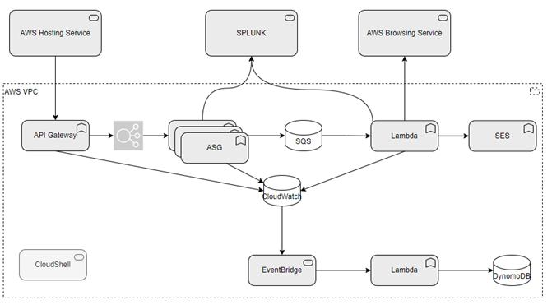

Technology Components & Architecture Impacts
List the technology components impacted by the change.
This is a snapshot of the CI lifecycle and risk rating at the time of the review. Use the NEW EXPERIENCE in ServiceNow for the best experience. The first time you use SN to gather this data, use this link to the CMDB. Open the ‘Update Personalized List’ gear on upper right of the screen. Add the Application IT Compliance and Number (u_ci_id) to your column list. When you find the application you are looking for, select the hyperlinked text under the Application IT Compliance column and NOT the Name column.
Technology Component Type | Technology Component Name | CMDB ID | Architecture Impact | Tech Lifecycle Strategy | Application Risk Rating
Business Application, Software, Hardware, Cloud Component | Application Name, Software Name, Hardware Name, Cloud Component Name | CMDB ID if in the CMDB  If not in the CMDB, indicate ‘New’  Prior to Project Solution - Final ARB, ‘New’ items must have a CMDB id to receive a passing score within the Architecture Alignment to Standards scorecard | Replace, Decom, Migrate, Re-use, Enhance, New | Buy, Hold, Sell  This is located in the Application IT Compliance Data in CMDB.  Search for the application an select the latest UPDATED date. The Application Lifecycle Strategy is on the right | Application Risk Rating is found by clicking on the link within the Application IT Compliance Data tab at the bottom of the application’s CMDB entry
Business Application | ServiceNow | CI002457504 | Reuse | Buy | High

Gap Analysis
What is changing from Baseline to Target. This is a more detailed description of the changes to the architecture, change in component usage, etc. If Greenfield, then N/A.

Components

Components or Patterns Used
This will include the logical high-level architecture diagram based on the previous contextual diagram and a list of components used in the solution (use links when possible).
GTS Component Architecture Standards (sharepoint.com)
GTS Reference Architectures (sharepoint.com)
GTS Architectural Patterns (sharepoint.com)

Component Architecture Diagram
Insert the component architecture diagram(s) as needed. This is intended to break down overview diagram when needed and highlight the components and their current use state.
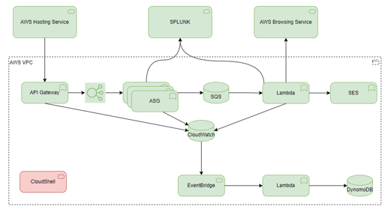

Components or Pattern Table
Components/Patterns Used |  | Link | Version
1
2
3
4
5
6

Integration Architecture
Populate the integration architecture table and provide the integration architecture diagram illustrating the relationships between technology components and the security integration patterns used.

Integration Architecture Diagram
Insert the integration architecture diagram. Include a link to the source file for the diagram for future reference or revisions.
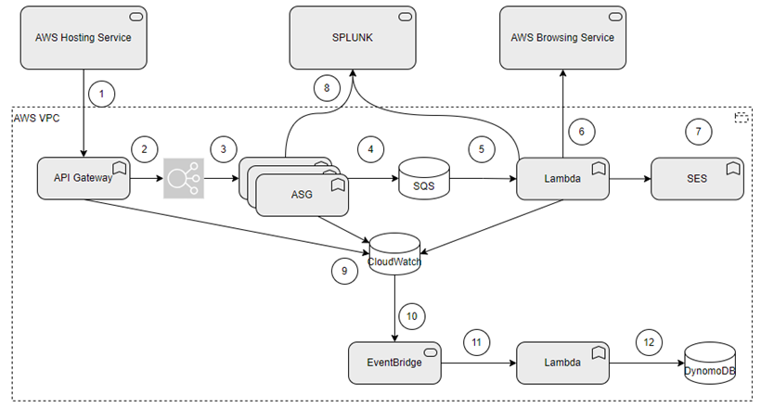

Integration Architecture Table
Connection | Source  Component | Target  Component | Purpose | Security Integration Pattern Name
1
2
3
4
5
6

Data Flow
Insert the data flow diagram. Include a link to the source file for the diagram for future reference or revisions. If the solution does not include a data flow, insert N/A.

Data Flow Diagram
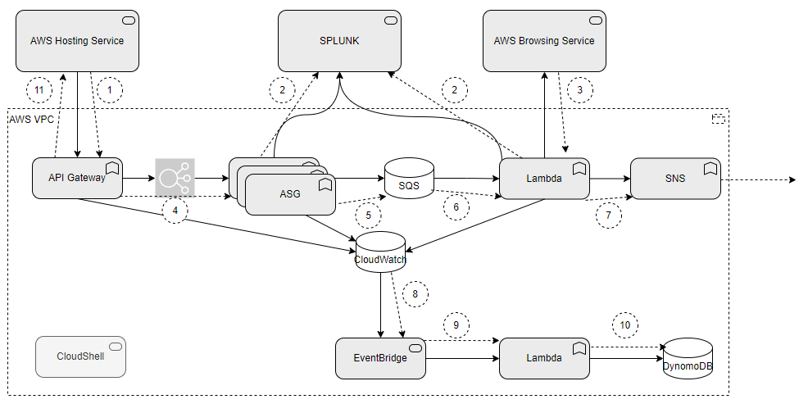

Data Flow Table
Data Flow Reference |  | Description
1
2
3
4

Data Protection

Backup and Recovery
The solution ensures resiliency and rapid recovery as a Terraform-managed application deployed via CI pipelines, meaning no source code is stored within the functional environment, while operational continuity is maintained through a system design that automatically falls back to manual security reviews in the event of an unrecoverable automated processing failure.

High Availability
The solution is hosted in AWS leveraging multi AZ deployment to ensure high availability, with SLA of 95%.

Disaster Recovery
In case of an unrecoverable failure the team will fallback to manual security reviews.

Observability
The solution maintains comprehensive observability through CloudWatch logging and DynamoDB audit trails, tracking every pull request’s validation status and system performance metrics. All Lambda and Step Function logs are retained for 30 days to facilitate troubleshooting. Real-time visibility is provided via MS Teams notifications

Authentication and Authorization
Access to Jira and Github repository is achieved by using OAuth 2.0 authentication.
The solution adheres to the principle of least privilege by assigning unique IAM roles to each infrastructure component

Security Boundaries
This section is intended to highlight the security boundaries in the proposed solution. A security boundary is a link between a role\user\system and a component of the proposed solution. In this section the aim is to highlight boundaries in the diagram and capture them, with a short description in the table. Boundaries to existing approved patterns should be highlighted.
The requirement for a threat model assessment will be highlighted during the security review and/or if the Architect has identified significant risk from the identified boundaries in the solution. The use of existing patterns would not normally necessitate a threat model assessment.

Security Boundaries Diagram
Provide a diagram of the security boundaries for assessment by the BU/GTS Security Team.
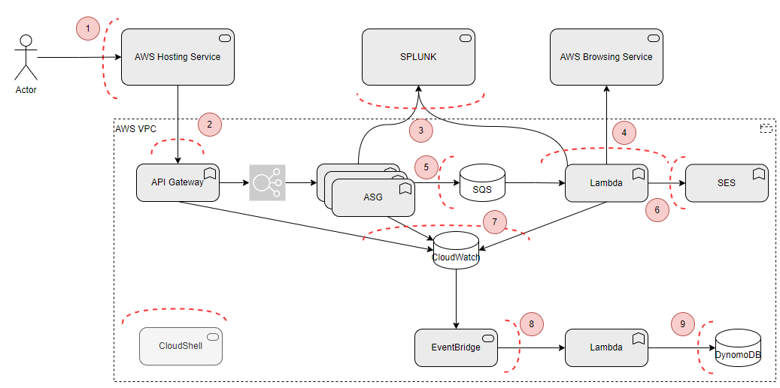

Security Boundaries Table
Security Boundary Reference |  | Existing Pattern | Description
1 | Firewall
2
3
4
5
6

Security Review Outcomes
Detail any significant outcomes, risks or recommendations highlighted in the security review (GTS ISO).
Text

Threat Model Assessment
If a Threat Model Assessment is needed, please complete this section/activity.
Open a Service Request to have a Threat Model Assessment Completed. Include this document and any supporting documented in the service request. After the assessment is complete, return to this document and modify the design/controls/governance to account for proper mitigation of the threats.

Threat Model Assessment Service Request number: XXXXXXXXXX

Data Solution

Data Classification
Make a selection in BOTH columns. Make a selection in BOTH columns.
Data Confidentiality Classification |  |  |  | Data Legal and Regulatory Classification
☐ | Strictly Confidential |  | ☐ |  | Financial Information
☐ | Confidential |  | ☒ |  | Personal Identifiable Information
☐ | Internal |  | ☐ |  | Protected Health Information
☒ | Public |  | ☐ |  | Payment Card Information
☐ | No Data Shared |  | ☐ |  | No Personal Data Shared

Privacy Impact Assessment (PIA)
Work with the Data Officer to assess the potential impact on the privacy of individuals. Include the PIA reference
Text

Data Encryption
Describe the requirements data encryption at rest and in transit. Refer to data security requirements for minimum requirements for data encryption and security. If data is not in scope for the solution, then state N/A.
e.g. Data in transit is being encrypted via SSL TLS1.2 at minimum.
Data at rest in S3 and Dynamo DB is encrypted using SSE-S3 ???
Data in transit with API endpoint (Github, Jira, LaunchPad) is encrypted with TLS1.2+

Data Retention
Describe unique data retention requirements to be considered when architecting the solution. If unique data retention requirements are not in scope for the solution, then state N/A.
Text

Data Residency
The solution is deployed in Aegon’s AWS North Virginia region.

GenAI
Include GenAI inventory number or type type Not applicable
Text/Links/Checkboxes….
Aegon GenAI - Home (sharepoint.com)
Gen AI Policy

Service Model
Discuss the operational support of the solution. Who is going to support each component? Are there specific SLAs? What is the overall SLA and how does it tie to the Resiliency Matrix?
Text

Shared Responsibilities
Consider allocating responsibility for different components, risks, processes, and artefacts.
This is especially important if responsibility is split between business units, or Aegon and third-party providers.
Cloud architectures should make special reference to the cloud service provider’s shared responsibility model.
ACE should also provide a shared responsibility model.

RACI Chart
Below is a template for a comprehensive RACI. A more focussed version will usually suffice.
Other stakeholders might include FRC (First Line Risk), Chief Data Officer, CTO and CEO.
Key Activity, Milestone, or Decision | Business Units | Global Enterprise Architecture | Global Infrastructure Platform Engineering | Global Information Security Services | BISO
Application Security Governance
Own Application Security capability | C/I | C/I | C/I | R/A | C/I
Define and maintain (adoption) strategy | C/I | R/A | C/I | R/A | C/I
Communicate (adoption) strategy | C/I | C/I | C/I | R/A | C/I
Define and maintain roles & responsibilities | C/I | C/I | C/I | R/A | C/I
Align Security strategy with Business Objectives | C/I | C/I | C/I | R/A | C/I
Define and describe policies & standards | C/I | C/I | C/I | R/A | C/I
Define application security objectives | C/I | C/I | C/I | R/A | C/I
Architecture
Create Tooling Architecture | C/I | R/A | C/I | C/I | C/I
Arrange ARB approval | C/I | R/A | C/I | R/A | C/I
Tooling implementation & Maintenance

Define tooling requirements | C/I | C/I | C/I | R/A | C/I
Select tools | C/I | C/I | C/I | R/A | C/I
Arrange required budget for tooling licences | C/I | C/I | R/A | C/I | C/I
Arrange required budget for resources maintaining tools |  |  | R/A | C/I | C/I
Implement and maintain tools | C/I | C/I | R/A | C/I | C/I
Implement required integrations | C/I | C/I | R/A | C/I | R
Conduct license management | C/I | C/I | R/A | C/I | C/I
Implement required reporting | C/I | C/I | R/A | C/I | C/I
Automate manual and repeatable activities | C/I | C/I | R/A | C/I | C/I
Deliver standard pipeline scanning building blocks | C/I | C/I | R/A | C/I | C/I
Organise DevSecOps community sessions | C/I | C/I | R/A | C/I | C/I
Training, Education & Roll Out
Identify and deliver training capabilities | C/I | C/I | C/I | R/A | C/I
Conduct developer training | R/A |  | C/I | C/I | C/I
Conduct security officer training | C/I |  |  | C/I | R/A
Conduct security awareness sessions | C/I | C/I | C/I | R/A | C/I
Conduct DevSecOps assessment per BU | C/I | C/I | C/I | C/I | R/A
Deliver Improvement plan as outcome of DevSecOps assessments | C/I |  |  | C/I | R/A
Ensure sufficient time is available for vulnerability remediation | R/A |  |  |  | C/I
Check scanning reporting results | R |  |  |  | R/A
Escalate to management if right follow up on scanning results and reporting is lacking | C/I |  |  | C/I | R/A
Scanning and mitigation
Conduct scanning | R/A |  | C/I | C/I
Prevent and resolve software security issues | R/A |  |  |  | C
Request false positive or exception check if required | R/A |  |  |  | C/I
Judge outcome false positive or exception requests | C/I |  |  |  | R/A
Administer outcome in ServiceNow VR | C/I |  |  |  | R/A

Implementation Approach

Proposed level of coordination
High Level list of activities and teams
Cloud Foundation Team: Deployment of solution
…

Dependencies
Text

Waivers and/or Exceptions
GTS Architecture Review Board (ARB) provides a governance framework for Architecture Risk. The GTS ARB will review and approve/reject solution Architecture Exceptions.
See this link for documentation related to Exceptions to Standards.
<start of excerpt from the above document>
The GTS ARB holds the responsibility for ensuring that risk acceptances and/or risk remediations for exceptions to standards are approved and documented within architecture templates before granting GTS Final ARB approval. The assigned architect is responsible for memorializing the GTS Risk Acceptances and GTS Risk Remediations within the Waivers and/or Exceptions section of the architecture template that is being presented for GTS ARB approval.
Risk Acceptance and Risk Remediation compliance is a function of the GTS internal risk management process. Exceptions to standards are logged as GTS Risk Acceptances or GTS Risk Remediations.
- GTS Risk Acceptances are logged for exceptions to standards that are not planned to be remediated. GTS Risk Acceptances will be reviewed annually though the GTS first line risk and control process to ensure that the risk acceptance without remediation remains acceptable.
- GTS Risk Remediations are logged for exceptions to standards that are intended to be remediated. Risk remediations require a remediation plan with a remediation date that identifies the commitment to remediate the risk. GTS Risk Remediations are required to be remediated within 12 months.
<end of excerpt from the above document>

Risk Acceptances
# | Acceptance Title | Exception Description | Link to Risk Exception Acceptance
1
2
3

Risk Remediations
# | Remediation Title | Exception Description | Link to Risk Exception Remediation
1
2
3

Security Exceptions
# | Exception Title | Exception Description | Link to Security Exception
1
2
3

Estimated Costs
This is an estimate of the cost of the solution, based on the known scope and requirements. This cost contains an estimate of the labour required to implement the solution, and the ongoing annual running cost of the solution with the servers turned on 24/7. This is not a quote and is subject to change if added information becomes available, the scope or requirements change, or if GTS’s service offerings and rates change.
SaaS Costing Template – This can be used for “simple” efforts to provide high-level costs

Financial Considerations
Text

Non-Financial Considerations
Text

Cost Benefit Analysis
Example cost benefit analysis table:
Compare proposed service / capability / solution against the as-is scenario.
If possible, also against any closely matched alternative solutions.
Values in USD
Current Form |  | Current Year | +1 | +2 | +3
Internal | Existing 0.5 FTE | 0.079 | 0.079 | 0.079 | 0.079
External | New 1.0 FTE | - | 0.159 | 0.159 | 0.159
Solution A | Infrastructure agtawsaus | 0.032 | 0.032 | 0.032 | 0.032
Ext’ Service | AWS Config | - | 0.720 | 0.720 | 0.720
Total |  | 0.159 | 1.037 | 1.037 | 1.037
Proposed New Form [Assumes 1 Jan '26 start date] |  | Current Year | +1 | +2 | +3
Solution B | Licence / subscription | - | 0.250 | 0.214 | 0.214
Internal | Existing 0.5 FTE | 0.079 | 0.079 | 0.079 | 0.079
External | 6 Month contractor | - | 0.150 | - | -
Solution B | Infrastructure | 0.032 | 0.016 | - | -
Cloud Security | AWS Config | - | 0.360 | 0.360 | 0.360
Total |  | 0.159 | 0.879 | 0.653 | 0.653
Cost Differential |  |  | 0.158 | 0.384 | 0.384
 |  |  | 2025 | 2026 | 2027
Run | Current |  | 1.037 | 1.037 | 1.037
 | New |  | 0.729 | 0.653 | 0.653
 | Delta |  | 0.308 | 0.384 | 0.384
 |  |  | 2025 | 2026 | 2027
Build | Current |  | - | - | -
 | New |  | 0.150 | - | -
 | Delta |  | -0.150 | - | -

Licensing
Discuss how licensing is calculated (by user, server, etc.). Are there any architecture decisions that affect licensing and cost (like Windows desktop in AWS)
The solution is developed internally with no licensing is required.

Financial Assumptions
Text

Resourcing Considerations
Text

Exit Strategy
Example Exit Plan Components: A robust exit strategy may include:
- Risk Assessment: Identifying risks associated with vendor lock-in and potential exit scenarios.
- Data Migration Plan: Defining how data will be moved to an alternative solution.
- Application Transition: Ensuring applications can function seamlessly in the new environment.
- Contractual Considerations: Reviewing contracts and understanding termination clauses.
- Testing and Validation: Validating the exit plan through testing and simulations.
- Communication Plan: Informing stakeholders about the transition process.
Research and vet alternative solutions that meet or exceed the business and technical requirements. Develop a detailed exit strategy defined by:
- Method Selection
- Exit Scope and Timeline
- Roles and Responsibilities
- Contract Review
Appendix A: Architecture Review Board Scorecard
<link to scorecard>

Appendix B: Related Documents
Links and other pertinent references

Appendix C: Glossary of Terms and Acronyms

